ASU – HBCU Clean energy summer Camp - 2025

Natural Sciences Department of Albany State University (ASU) will host a clean energy summer camp to expose high school students to solar energy related hands on STEM activities with sponsorship of Department of Energy.

**Project Title – Clean energy summer camp---a step toward a sustainable green society**

**Proposed Activities(1-week)**

1. **Report Time:** 9:30am Monday - Friday
2. **Session1:** June 2,2025|scientific knowledge about solar energy and its impact on environment/economy/society (the PI, Student researchers)
3. **Session 2**: June 3, 2025| hands-on training on fabricating solar cells and testing their performance (the PI, Student researchers)
4. **Session 3**: June 4, 2025| hands-on training on set-up various circuits which are powered by solar cells
5. **Session 4**: June 5, 2025, hands-on training projects how to utilized solar cells to power electric fan, light bulb and heater.
6. **Session 5**: June 6, 2025| hands on projects on training on the DIY solar kits for assembling and installing race car which is powered by fuel, battery or solar cells (Student researchers and Local professionals)

**Location** – Room # 232, BCB Building, ASU

If you allow your student/child to participate in the program, please complete & sign the following application and send it to the following address by mail or email **by May 15, 2025.**

Dr. Liqiu Zheng ([**Liqiu.Zheng@asurams.edu**](mailto:Liqiu.Zheng@asurams.edu)) Dr. Seong Seo( Seong.seo@asurams.edu)

Associate Professor, Physics ; 2295002320; Professor of chemistry; 2295002160

Albany State University, Albany GA 31705

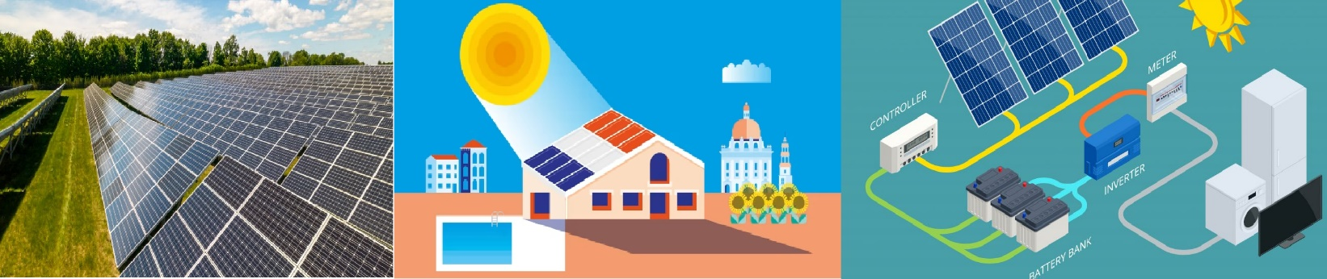

Application

My child _____________________ will participate in slot ____. I will drop and pick up my child to and from Albany State University.

Parent Signature____________________________

Parent Name: ______________________________

Parent Contact: _____________________________

Parent email: ______________________________

Name of Child’s School: _______________________

Child’s Grade: ______________________________

**In Case of emergency**

Name: ___________________________________

Relationship to Student: _______________________

Contact number: ____________________________

_______________________________________________________________________

Cost: $0; Lunch will be provided.

If you have any questions, please ask Dr. Lily Zheng @ [229-500-2320 or liqiu.zheng@asurams.edu](mailto:229-500-2320%20or%20liqiu.zheng@asurams.edu)

**RELEASE, WAIVER of LIABILITY and COVENANT NOT TO SUE**

**(READ CAREFULLY BEFORE SIGNING)**

I, ______________________________, the parent or legal guardian of _______________________, a student participating in the *Summer Computing Camp* at Albany State University during the week of June 4th to July 14th, 2024, hereby voluntarily enter into this Release, Waiver of Liability and Covenant not to sue on behalf of the above-named student, myself, our heirs, administrators, executors and assigns. I freely, voluntarily and knowingly grant permission to the above-named child to participate in the above activity, with the understanding that participation in experiments in the laboratory, even with the supervision of adult personnel and parent chaperones, involves certain inherent risks that cannot be eliminated regardless of the care taken to avoid injuries. In consideration for the privilege of my child participating in this activity, I freely, voluntarily and knowingly assume all risks on behalf of my child as his/her parent or legal guardian. I further certify that there are no health-related problems or other reasons that would preclude the above-named student’s participation in this activity or event.

I further agree to abide by all policies, rules and regulations of the Board of Regents of the University System of Georgia, Albany State University (ASU) and the ASU Department of Natural Sciences, and that I will reinforce rules of conduct imposed by the coordinators of this activity by discussing said rules with the student above-named.

In consideration for the participation of the above-named student in the activities above described, including, but not limited to, travel to and from said event and all activities associated with said event which may also involve inherent risks, I hereby indemnify, release, hold harmless and covenant not to sue the Board of Regents of the University System of Georgia (hereafter BOR), Albany State University (hereafter ASU), their trustees, officers, agents, and employees from any and all liability, claims, demands, actions and causes of action whatsoever arising out of or relating to any loss, damage or injury, including death, that may be sustained by the above-named student, or damage to any property belonging to said student, whether caused by the negligence of the BOR or employees of ASU, or the result of defective equipment or property owned, maintained, or controlled by them, or because of their possible liability without fault.

**I have carefully read and fully understand the contents of this entire document, and consent, individually and on behalf of the above-named student, to the provisions contained herein.**

**IN WITNESS WHEREOF**, I set my hand hereto as of the date set forth below:

____________________________________ ____________________

**Signature of Parent/Legal Guardian Date**

____________________________________ ____________________

**Witness Date**

Health Form

**PARTICIPANTS MUST HAVE MEDICAL INSURANCE**

Name of Participant _______________________________________________

Date of Birth __________________ Age __________ Gender_____________

Family Physician Name ___________________________________________

Family Physician’s Phone Number __________________________________

Medical Insurance Provider Name __________________________________

Group Number _________________________________________________

**AUTHORIZATION FOR MEDICAL TREATMENT**

(The completed form must be on file before treatment is administered.)

I give my permission for diagnostic, therapeutic, and operative procedures as may be deemed necessary for my son / daughter / ward.

Parent or Legal Guardian's signature is REQUIRED below if the student is less than eighteen years of age.

Name of Participant: __________________________________

Name of Parent or Legal Guardian: ______________________

Signature of Parent or Legal Guardian: ____________________

Date of Signature: _____________________________________