Safety is everyone’s responsibility! Whether you’re a pedestrian or a driver, following the rules ensures safer roads for everyone.

**Crossing Streets Safely:**

* Walk on sidewalks whenever they are available.
* Cross streets at crosswalks or intersections.
* Look both ways before crossing the street.
* Look to see if cars are approaching the intersection to turn.
* Be aware of what the traffic lights indicate.
* Be attentive to the crossing signal and be mindful of its instructions.
* Don’t walk in front of traffic when it is impractical for the driver to yield.
* If you walk outside a crosswalk you must yield the right of way to vehicles.
* Vehicles should stop and remain stopped to allow you to cross the roadway within a crosswalk.
* Whenever a vehicle is stopped at a crosswalk, watch for other vehicles approaching.

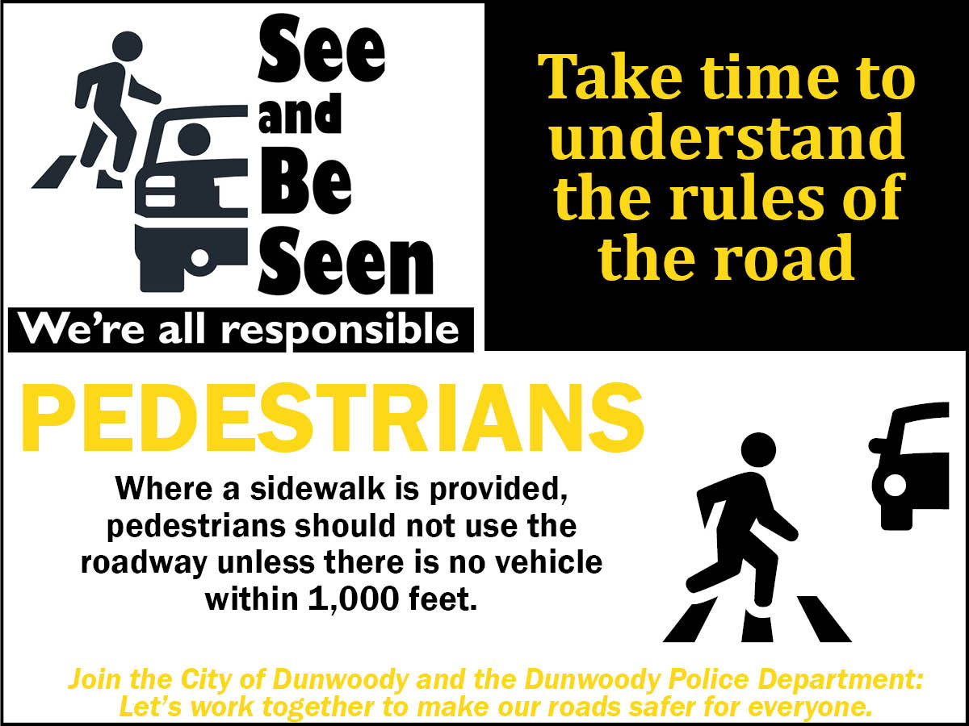

Pedestrian Safety

Play it Safe at Albany State!

Albany State University  
Police Department

229-430-4711



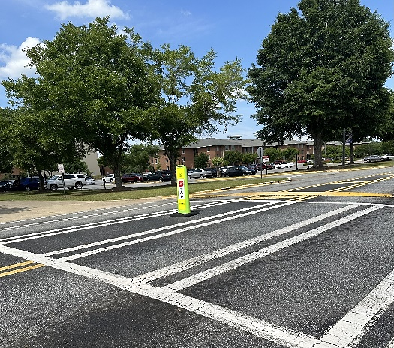



**GA – Official Code of Georgia Annotated O.C.G.A. § 40-6-92:**

(a) Every pedestrian crossing a roadway at any point other than within a marked crosswalk or within an unmarked crosswalk at an intersection shall yield the right of way to all vehicles upon the roadway unless he has already, and under safe conditions, entered the roadway.  
(b) Any pedestrian crossing a roadway at a point where a pedestrian tunnel or overhead pedestrian crossing has been provided shall yield the right of way to all vehicles upon the roadway if he uses the roadway instead of such tunnel or crossing.  
(c) Between adjacent intersections at which traffic-control signals are in operation, pedestrians shall not cross at any place except in a marked crosswalk.  
(d) No pedestrian shall cross a roadway intersection diagonally unless authorized by official traffic-control devices. When authorized to cross diagonally, pedestrians shall cross only in accordance with the official traffic-control devices pertaining to such crossing movements.

Georgia Laws on Pedestrian Safety:

**GA - Official Code of Georgia Annotated O.C.G.A. § 40-6-96:**(a) As used in this Code section, the term “pedestrian” means any person afoot and shall include, without limitation, persons standing, walking, jogging, running, or otherwise on foot.  
(b) Where a sidewalk is provided, it shall be unlawful for any pedestrian to stand or stride along and upon an adjacent roadway unless there is no motor vehicle traveling within 1,000 feet of such pedestrian on such roadway or the available sidewalk presents an imminent threat of bodily injury to such pedestrian.

**GA- Official Code of Georgia Annotated O.C.G.A. §40-6-95:**A person who is under the influence of intoxicating liquor or any drug to a degree which renders him a hazard shall not walk or be upon any roadway or the shoulder of any roadway. Violation of this Code section is a misdemeanor and is punishable upon conviction by a fine not to exceed $500.00.

**GA - Official Code of Georgia Annotated O.C.G.A. §40-6-97:**(a) No person shall stand in a roadway for the purpose of soliciting a ride.  
(b) Except as provided in Code Section 40-6-97.1, no person shall stand on a highway for the purpose of soliciting employment, business, or contributions from the occupant of any vehicle.  
(c) No person shall stand on or in proximity to a street or highway for the purpose of soliciting the watching or guarding of any vehicle while parked or about to be parked on a street or highway.

Our streets are not just for cars. We share them with pedestrians, bicyclists and public transit. By knowing the rules, we can help make Albany State University safer for the campus community!

**Safety Tips for Drivers:**

* Look out for pedestrians everywhere, at all times.
* Use extra caution when driving in hard-to-see conditions, such as nighttime or bad weather.
* Slow down and be prepared to stop when turning or otherwise entering a crosswalk.
* Yield to pedestrians in crosswalks and stop far enough from the crosswalk to give other vehicles an opportunity to see the crossing pedestrians so they can stop too.
* Never pass vehicles stopped at a crosswalk. There may be people crossing where you can’t see.
* Follow the speed limit, especially around people on the street, in school zones and in areas where children are present.
* Be extra cautious when backing up and look for pedestrians.

